

**Name:** O G Ragavi **Slot**: L31+32

**Reg No:** 20BCE1988 **Date: 19.09.2022**

**Lab Ex:** 7

—------------------------------------------------------------------------------------

Q1) **Code:**

<?php

$a=(int)readLine("Enter a:");

$b=(int)readLine("Enter b:");

$i=0; if($a<$b)

{

for($i=$a+1;$i<$b;$i++)

{ echo($i*$i)."\n";

}

}

else

{ echo("Invalid");

}

?>

**Output:**

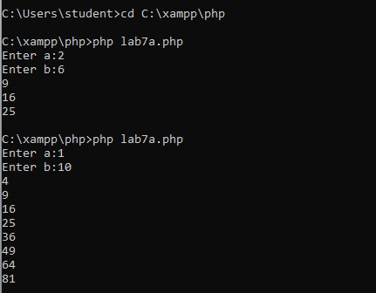

**Q2) Code:**

<?php

$i=0;

$tot=10000; for($i=0;$i<3;$i++)

{

$a=(int)readLine("Enter the target in percentage:"); if($a==100)

{

$tot=2*$tot;

}

elseif($a>=75 && $a<100)

{

$tot=$tot+0.5*$tot;

}

else

{

$tot=$tot+0.1*$tot;

}

echo("Salary of employee is ".$tot)."\n";

}

?>

**Output:**

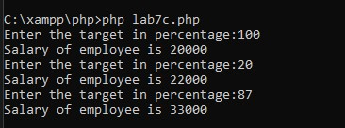

**Q3) Code:**

<?php

$a=(int)readLine("Enter value 1:");

$b=(int)readLine("Enter value 2:"); $c=(int)readLine("Enter value 3:");

$d=(int)readLine("Enter value 4:");

$e=(int)readLine("Enter value 5:");

$sum=$a+$b+$c+$d+$e; $prod=$a*$b*$c*$d*$e; if($a==$b || $a==$c||$a==$d||$a==$e)

{

echo("DUPLICATES"); echo(3*$sum);

} elseif($b==$a||$b==$c||$b==$d||$b==$e)

{

echo("DUPLICATES"); echo(3*$sum);

}

elseif($c==$a||$c==$b||$c==$d||$c==$e)

{

echo("DUPLICATES"); echo(3*$sum);

}

elseif($d==$a||$d==$b||$d==$c||$d==$e)

{

echo("DUPLICATES"); echo(3*$sum);

}

else

{

echo("ALL UNIQUE"); echo(2*$prod);

}

?>

**Output:**

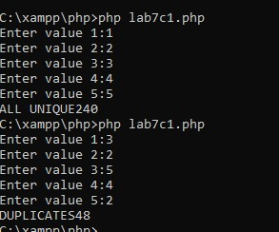

**Q4) Code:**

<?php

$n=(int)readLine("Enter the value of n:");

$m=(int)readLine("Enter the value of m:");

$points=0; if($n<$m) echo("Invalid"); else

{

$points=($n*$n)-($m*$m); echo($points);

}

?>

**Output:**

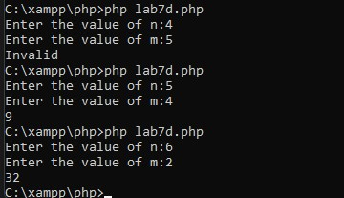

Q5) **Code:**

<?php

$books_taken=0;

$books_issued=0;

$updated=0;

$books_returned=0;

$option=(int)readLine("Enter the option:"); if($option==1)

{

$books_taken=(int)readLine("\nEnter the no of books taken: ");

$books_issued=(int)readLine("\nEnter the no of books to be issued:");

$tot=$books_taken+$books_issued; if($tot>10){

$updated=$books_taken; echo("Full\n");

}

else

$updated=$tot;

}

elseif($option==2)

{

$books_taken=(int)readLine("\nEnter the no of books taken: "); $books_returned=(int)readLine("\nEnter the no of books to be returned:");

if($books_returned>$books_taken){ $updated=$books_taken; echo("Invalid\n");

}

else

{

$updated=$books_taken-$books_returned;

}

echo("The final updated books taken is: ".$updated);

}

?>

**Output:**

